Redcliffe State High School
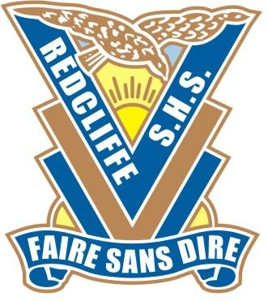

School of Excellence
in Rugby League

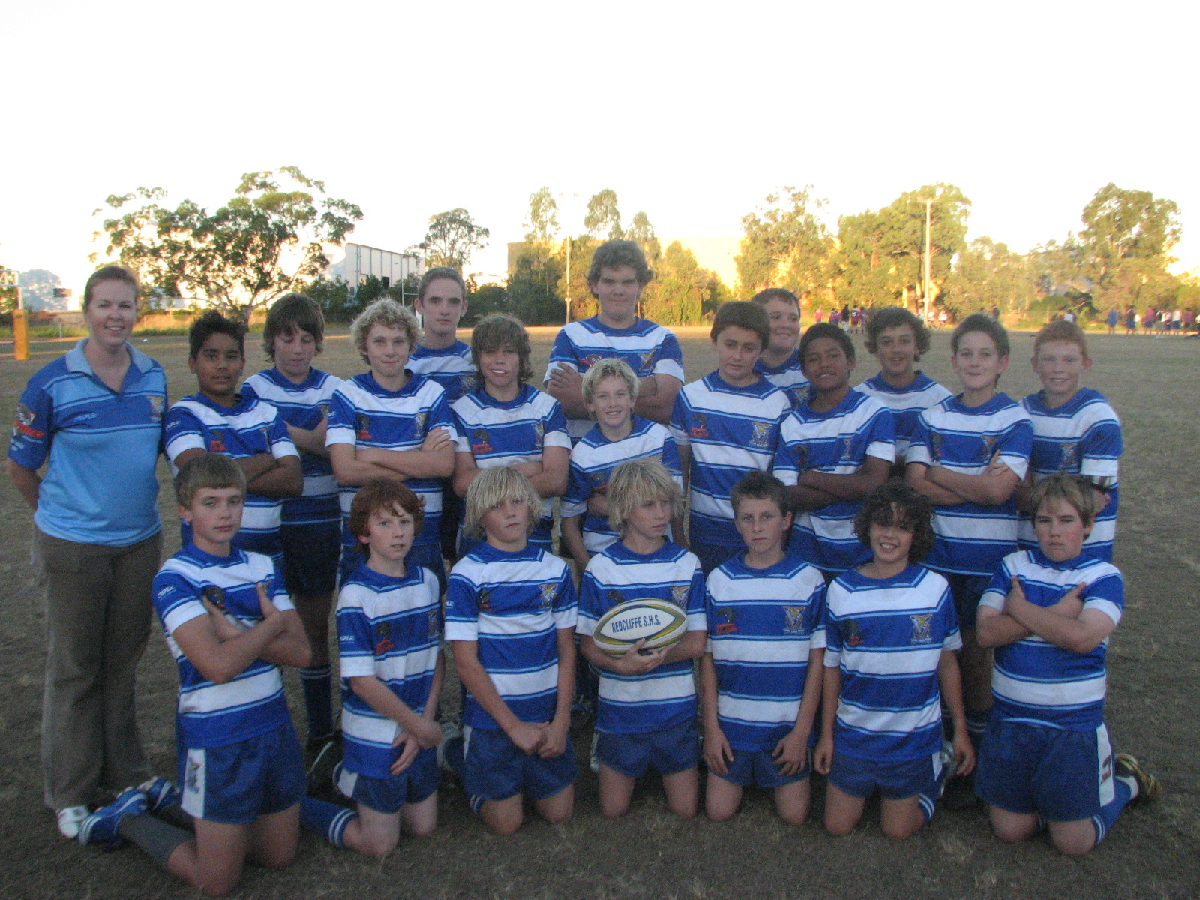
The 2007 Year 8 Aspley Bronco team and coach, after another exciting win in the Aspley Broncos Year 8 Ski Fleet Toyota Challenge
ENROLMENT
PROPOSAL
REDCLIFFE STATE HIGH

School of Excellence
Rugby League Program





Dear Parent/Caregiver,

Before the new year commences I would like to take this opportunity to introduce myself. My name is Tony Guilfoyle and as Rugby League Excellence Program Director my role is to oversee the development of the Rugby League Program.

The core values of the Redcliffe State High School Rugby League Excellence Program:

Whilst student’s football and athletic abilities have created an opportunity to participate in the program it will be their attitude towards behaviour, their application to curriculum and general participation within the school community that will provide them with success now and in the future.

Through discussions with Administration, HOD HPE/Sport and Rugby League Excellence teachers it was established as a high priority that all members within the program should value all aspects of the school community. If students fail to display a consistent attitude of excellence in their behaviour and academic pursuits then the privilege of being a part of this program will be withdrawn.

“If I knew I had 6 hours to chop down a tree I would spend 4 hours sharpening the axe”.
ABRAHAM LINCOLN

The scoreboard will not be a measure of the programs success. The Rugby League Excellence Program goals will be to foster individual excellence within:
- Academic Success
- Community Involvement
- Interpersonal Development and
- Rugby League

It is our belief that the time spent fostering these goals will make chopping down the tree more effective and in the long term more successful and rewarding. It is our goal to create Resilience, Persistent, Competitive, Innovative and Respectful individuals. These are high goals but it is hoped that we will work in partnership with parents and caregivers in achieving the goals above.

We look forward to your continuing support throughout 2007. If you have any queries or concerns please contact me through the school on the number below.

Tony Guilfoyle
Program Director
SOE – Rugby League


Redcliffe State High School ● School of Excellence - Rugby League
P O Box 510 Redcliffe QLD 4020 ● P 3897 1111 F 3897 1100 W www.redcliffeshs.qld.edu.au

Redcliffe State High

Rugby League Excellence Program

Dear Parents/Caregivers,

Redcliffe State High School is one of the oldest and proudest schools on the Redcliffe Peninsula. At Redcliffe State High School, we are committed to providing quality education in a manner that reflects the needs of today’s students.

To demonstrate our commitment to achieving ‘Above and Beyond’ outcomes for our students, Redcliffe High in 2001 commenced an Excellence Program in Rugby League. This course has proved to be extremely popular with boys and is again being offered to students entering Year 8 in 2008. The course will cover four semesters over Years 8 and 9. Students will further develop their skills while learning about many other aspects of the game. Subject results will be recorded on students’ reports. These Junior units will flow into the Senior School of Excellence in Rugby League Program in Years 10, 11 and 12. These programs are being offered to prepare players for possible careers in Rugby League and allied industries.

Redcliffe Leagues Club endorses the program and their support extends to assistance in coaching clinics with senior club players and coaches as well as providing playing and training outfits. The Program Co-ordinator is Mr Tony Guilfoyle a Level 1 Coach and current Strength and Conditioning Director for the Redcliffe Dolphins. Mr Michael Roberts, Redcliffe’s Queensland Cup Hooker, and current QRL Player of the Year also coaches teams and takes Rugby League and HPE classes. The 2007 senior team will be coached by Head of Department of HPE/Sport at Redcliffe State High School, Mr Brendan Barlow, a Level 2 Coach who has won a National Schoolboys titles and is the current Queensland U18s Schoolboys Representative Coach. Our teams will compete in the Arrive Alive Cup and Broncos Challenge. Mr Grant Cleal, the Redcliffe Leagues Club Development Officer will also be involved in the development of the course content and coaching matters. Playing/training fields have already been developed and the school has a gymnasium which boys in the program use extensively.

We would like to offer you the opportunity to apply for a position in the Redcliffe State High School of Excellence – Rugby League Program. The chance to further develop your Rugby League skills while studying at one of South-east Queensland’s most innovative schools is unique. Boys in the School of Excellence Program will have the opportunity to play in competitions that no other schools on the Redcliffe Peninsula have. These competitions include the U13, U14, U15 and 18 years elite South-East Qld Broncos Challenges which feed into the National Arrive Alive Cup.

Please fill out the application form and return it to the school Administration Staff located in the school office as soon as possible after the 9th July, 2007 as places are strictly limited.

Should you have any questions about the program or the school, please do not hesitate to contact me on 3897 1111. An information night for parents intending to send their children to Redcliffe State High School will also be held later in the year.

I look forward to your response.

Yours in Rugby League

Tony Guilfoyle Brendan Barlow Shona McKinlay
Program Coordinator HOD HPE/Sport Principal
SCHOOL OF EXCELLENCE
RUGBY LEAGUE

ATTENTION TO PARENT / GUARDIANS
RE: ENROLMENT PROCESS 2008

ENROLMENT FORMS WILL NOT BE ACCEPTED UNTIL MONDAY 9TH JULY, 2007 - FIRST DAY OF TERM 3.

All enrolment forms must be hand-delivered to the Redcliffe State High School Administration office. When completed forms are being handed in, you must ensure that the Birth Certificate of the student to be enrolled at Redcliffe State High School is produced to the Administration Officer along with your (Parent/Legal Guardian) current photographic ID – Driver’s Licence or 18+ card.

If these two items are not produced to the Administration Officer, your enrolment forms will not be accepted and you will be asked to return at a later time WITH those documents.

Once all enrolment forms and identification/address details are confirmed, your child’s application will be considered for enrolment at Redcliffe State High School in 2008. Please note that this is an application process ONLY and all enrolment applications face approval by the principal before being officially enrolled as a student.

If you have any further queries regarding enrolment procedures at Redcliffe State High School, please contact the school Administration office by phone on 3897 1111.

School of Excellence

Rugby League

REDCLIFFE STATE HIGH SCHOOL

APPLICATION FORM 2008 ENTRY

PLEASE NOTE: Enrolment forms will not be accepted before 9th July, 2007

PERSONAL DETAILS

STUDENT’S FULL NAME:

DATE OF BIRTH:

ADDRESS:

HOME PHONE: MOBILE NO:

PARENT / GUARDIAN DETAILS

PARENT 1 FULL NAME:

HOME ADDRESS:

HOME PH: _______________ MOBILE NO: ___________________WORK NO: _______________

PARENT 2 FULL NAME:

HOME ADDRESS:

HOME PHONE: MOBILE NO:

Redcliffe State High School Cnr Oxley Avenue & Klingner Road, Redcliffe 4020
PO Box 510 Q 4020 W www.redcliffshs.qld.edu.au
Telephone (07) 3897 1111 Fax (07) 3897 1100
SCHOOL DETAILS

PRESENT SCHOOL:

INTENDED YEAR LEVEL 2007:

RUGBY LEAGUE BACKGROUND
CURRENT CLUB: AGE: DIVISION:

POSITION(S) PLAYED:

List your representative honours:

Please give details of previous clubs:

Year | Club | Age | Division

Give details of any recent coaching clinics or camps attended:

Please include other information you consider may be relevant to your application:

Redcliffe State High School Cnr Oxley Avenue & Klingner Road, Redcliffe 4020
PO Box 510 Q 4020 W www.redcliffshs.qld.edu.au
Telephone (07) 3897 1111 Fax (07) 3897 1100
Name one person who could give you a reference to enter this programme.

NAME OF YOUR REFEREE

CONTACT NO

RELATIONSHIP TO YOU ( COACH, TEACHER ETC)

Do you give us permission to contact them?
(Does your referee know that you have put their name in the above section? Please mention it to them, and check they are prepared to recommend you into our program)

CERTIFICATION

I certify that the information contained in and accompanying this application is correct and complete. I understand that the provision of misleading information may lead to the cancellation of my application.

SIGNED: (Applicant)

WITNESSED: (Parent/Guardian)

DATE:

Redcliffe State High School Cnr Oxley Avenue & Klingner Road, Redcliffe 4020
PO Box 510 Q 4020 W www.redcliffshs.qld.edu.au
Telephone (07) 3897 1111 Fax (07) 3897 1100
PERSONAL QUALITIES – student to complete

What personal qualities and attributes do you possess which would make you an asset to the Excellence in Rugby League Program?

If selected what are you hoping to gain from being in the Excellence in Rugby League Program?

What are your other interests/hobbies besides Rugby League?

At this time, what are your goals with regard to Rugby League / sport after completing school and the excellence program?

Redcliffe State High School Cnr Oxley Avenue & Klingner Road, Redcliffe 4020
PO Box 510 Q 4020 W www.redcliffshs.qld.edu.au
Telephone (07) 3897 1111 Fax (07) 3897 1100

REDCLIFFE STATE HIGH

Rugby League School of Excellence
Academic & Vocational Pursuits

The Redcliffe State High School Rugby League Excellence Program is determined to foster a culture of personal excellence and a desire to achieve personal successes within academic or vocational pursuits as well as students’ sporting endeavours.

Redcliffe State High School received two OP 1s in the exiting 2006 Year 12s. Our current male School Captain is also the Captain of the Opens Rugby League Excellence team. The Sporting Excellence Department aims to have all Rugby League students engaged in an OP academic course or employed in a School-based Traineeship/Apprenticeship program. Being educated and skilled off the field is the number one priority of the Redcliffe State High School Rugby League Excellence Program.
REDCLIFFE STATE HIGH SCHOOL
97%
98%
75%

Redcliffe State High School ● School of Excellence - Rugby League
P O Box 510 Redcliffe QLD 4020 ● P 3897 1111 F 3897 1100W www.redcliffeshs.qld.edu.au

