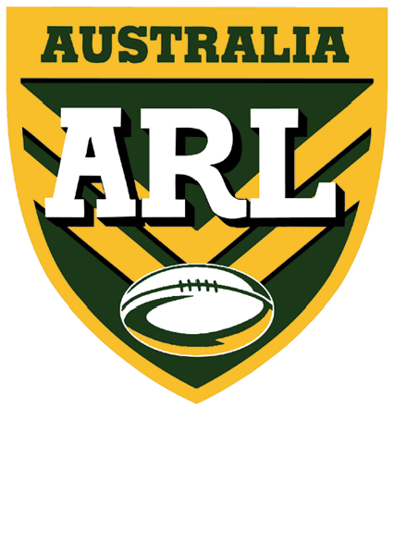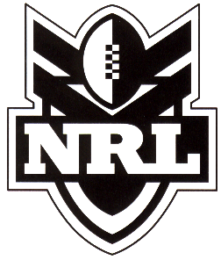
STATE OF ORIGIN
PACKAGES
For just $275.00 (includes GST & postage), a squad of 20 junior players
(17 yrs & under) and 5 adults can attend State of Origin 2 on
Wednesday, 13th June 2007 at Stadium Australia.

Tickets for Package holders will be Category 4 tickets ONLY!

There is a limit of 3 packages per Club.

There are a limited number of packages available.
They will be allocated on first in basis.

Payment must accompany this form –
no faxed requested will be considered.

Teams who wish to take advantage of this offer should send their cheque (payable to the NRL), together with the completed form below to:

NSWRL Academy, PO BOX 533 NARRABEEN NSW 2101
(Ph) 02 9971 0877
(E-mail) academy@nswrlacademy.com.au

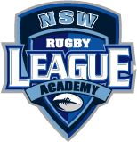

NAME OF TEAM: ___________________________________________________

TEAM ORGANISER’S NAME: _______________________________________

Ph: (B) __________________ (Fax) _______________ (Mob) ________________

POSTAL ADDRESS _________________________________________________

SUBURB: _______________________________ POSTCODE: ______________

State of Origin 2 □ Number of packages required: ________

Offer FOR SOO 2 closes: FRIDAY, 4th may 2007
(Unless fully subscribed prior to this date)

I have enclosed a cheque payable to the NRL for the total amount of $__________

No Credit card facilities available.

This offer is subject to availability!

