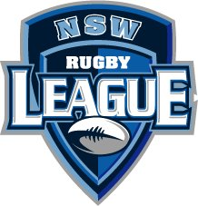
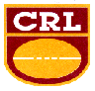
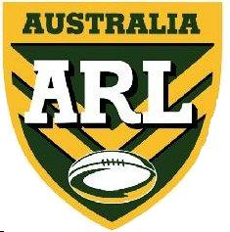

Level 2 First Aid Officers Rugby League
Course

22nd – 25th January 2006

A Nationally Recognised course that is Rugby League specific.

All Participants Receive:

- Top class tuition
- Motel room accommodation

All meals

Texts

National Accreditation (upon successful completion)

This course allows the candidate a chance to upgrade their skills. The course includes; Understanding how the body is constructed and its functions, Nutrition, Hydration and Drugs and the Rugby league Player, Extended Taping techniques, Specific Joint & Soft Tissue Injuries and Emergency Care (including Head & Spinal Injuries, Abdominal & Thoracic Injuries, Observational skills and Immobilisation & Removal techniques).

Eligibility
All candidates for the Level 2 Course must have attained the Level 1 FAO & completed 1 full season with a Rugby League Club. Other applicants will be considered after submission of appropriate qualifications

Applicants
Applications for the Level 2 FAO courses must be received by the NSWRL Academy by no later than 1st December 2006. The courses have a maximum of 30 participants and a deposit of $50.00 is required to ensure a position in the course. Total cost of this course is $460.00.

Location
Sydney Academy of Sport, Wakehurst Parkway, Narrabeen.

For further information, contact Yvette Downey at the Rugby League Academy on:
Ph: 02 9971 0877 Fax: 02 9971 0977 Mobile: 0407 466 633
Email: yvette@nswrlacademy.com.au

